**Assignment weeks 9, 10 and 11**

*To answer all the questions below, you must use Stata (and, specifically, DASP, if requested). Be concise and clear in your answers.*

*The assignment is divided into three exercises (the points assigned to each exercise are indicated next to each exercise). Please answer directly in this file after each question and please attach the *.do file (do-file) that you generated. Rename both files as: “Assignment weeks 9-10-11 - Name, Surname”. Please submit this completed file and the *.do through the virtual drop box (boîte de dépôt) in the course portal, no later than Tuesday, April 13 11:59 p.m. (*[***Québec time***](https://www.timeanddate.com/worldclock/converter.html?iso=20190410T035900&p1=189)*).*

# Exercise 1 (4.5%):

Assume that the population is composed of six individuals. The scores of each of the three dimensions of well-being are reported in the table below.

|  |  |  |  |
| --- | --- | --- | --- |
|  | $$w_{1}$$ | $$w_{2}$$ | $$w_{3}$$ |
| Individual 1 | 4 | 20 | 12 |
| Individual 2 | 8 | 12 | 0 |
| Individual 3 | 16 | 16 | 24 |
| Individual 4 | 12 | 12 | 16 |
| Individual 5 | 28 | 20 | 8 |
| Individual 6 | 24 | 16 | 12 |

Assume that the poverty threshold of each of the three dimensions is 14. Perform the following computations with Stata.

* 1. Using the union approach, estimate the proportion of poor individuals. Redo the estimation using the appropriate DASP command.

Union approach

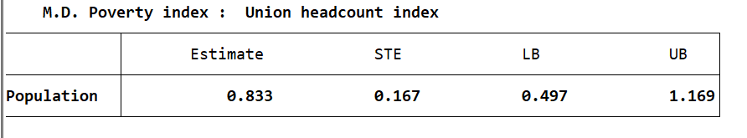

Using DASP

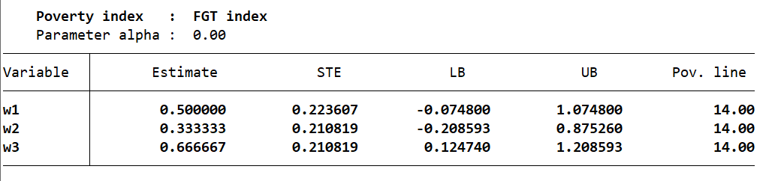

* 1. Using the intersection approach, estimate the proportion of poor individuals. Redo the estimation using the appropriate DASP command.

Intersection approach

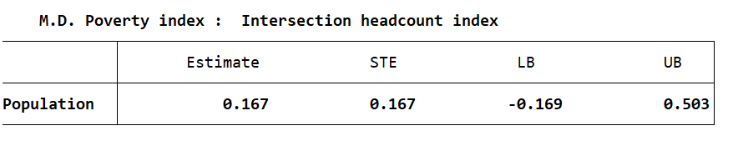

* 1. Which approach is more sensitive to the increase in individual multiple deprivations?
  2. Estimate the Alkire and Foster (2007) index MPI( $α=0)$ when the dimensional cut-off is equal to 2 (the poor are those with two or three dimensions of deprivation).

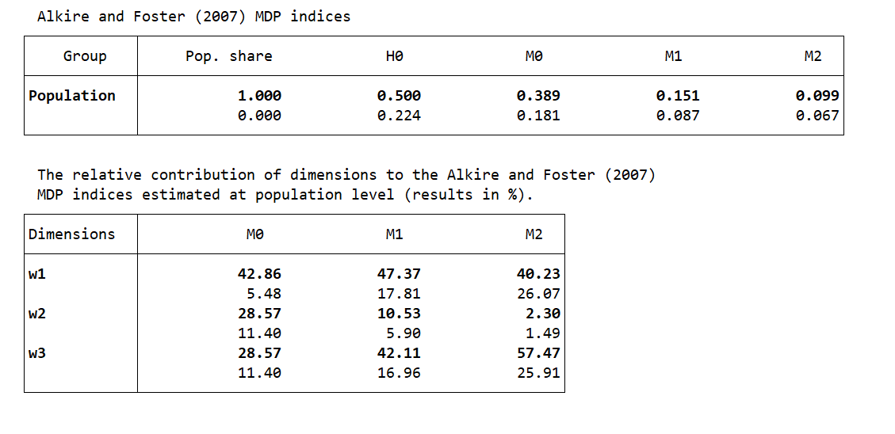

* 1. Now estimate the same indices using the appropriate DASP command. Discuss the findings.
  2. Assume that the government has 24$ and can target one dimension with a universal transfer. Which targeted dimension would most reduce the union index, and the intersection index? Discuss your findings.

# Exercise 2 (4%):

For the case of tri-dimensional well-being dimensions, the Bourguignon and Chakravarty (2003) poverty index (henceforth the BC index ) is defined as follows:

$${MDP}_{BC}=\frac{1}{H}\sum_{h=1}^{h}{π\text{(}w_{h}\text{; z) }}$$

Where $π\text{(}x_{h}\text{; z)}$ is the contribution of the individual $h$ to the total poverty:

$π\text{(}x_{h}\text{; z)=}{\left[β_{1}g_{h,1}^{ϵ}+β_{2}g_{h,2 }^{ϵ}+β_{3}g_{h,3}^{ϵ})\right]}^{\frac{a}{ϵ}}$*and $g_{h,i}=\frac{{\left(z_{i}-w_{h,i}\right)}_{+}}{z_{i}}$*

Using the data of exercise 1,

* 1. Estimate the Bourguignon and Chakravarty (2003) poverty index when .

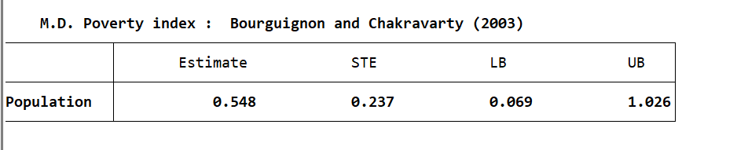

* 1. Redo the estimation using the appropriate DASP command.
  2. Generate three new variables (nw_*) wherein individuals equalize their well-being dimensions (example: gen nw_1 = (w_1+ w_2+w_3)/3) (i.e. For instance, individual 1 has 4, 20, 12 in the three dimensions respectively. After the equalisation, we will have: 12, 12, 12). Then, using DASP, re-estimate the BC index with the new vectors of well-being. Explain the direction of the change in the BC index.

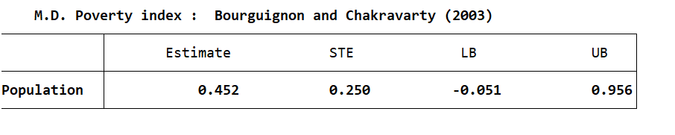

# Exercise 3 (4%):

The data file ***Canada_1996_2005_random_sample_3*** is a randomly drawn sample of 100 000 observations. It contains the information on gross incomes, taxes and transfers.

* 1. Using the observations from 2005, estimate the expected marginal tax, benefit and net income rates for the range of gross incomes between 1000 and 31000$ (hints: use the DASP ***cnpe*** command with the option: type(dnp)).

Marginal tax

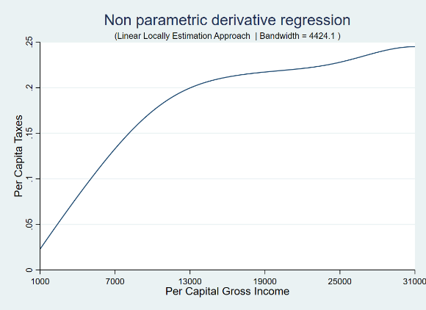

Benefit

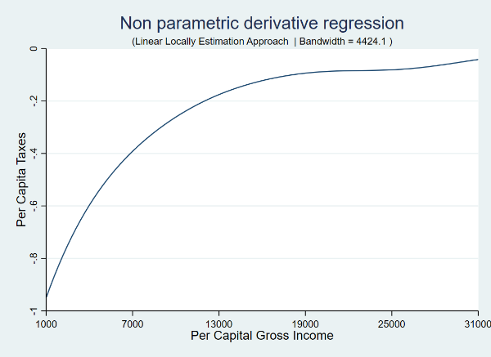

Net Income

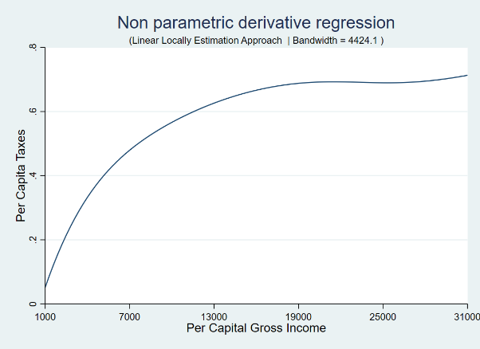

* 1. Estimate the redistributive impact on the Gini inequality index for the years of 1999, 2002 and 2005 (hints: use the Stata commands preserve/restore to preserve the data after using the Stata command keep if year==…).

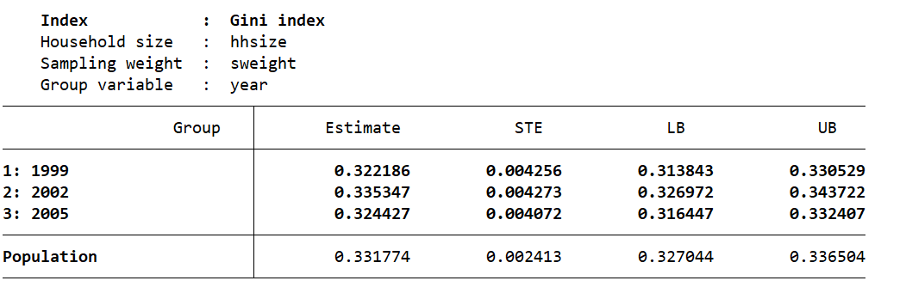

* 1. Estimate the Kakwani progressivity index per year using the DASP command ***iprog*** (hints: use the option gobs(year)).

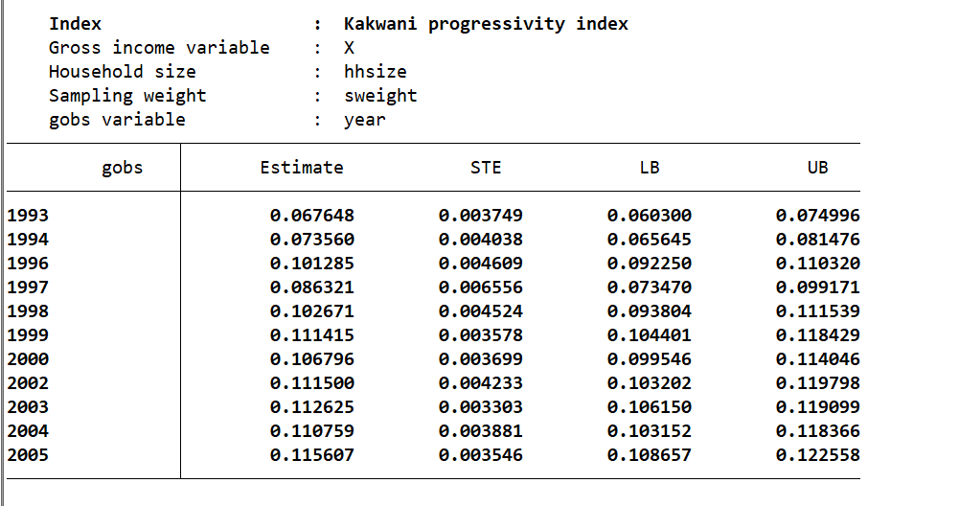

* 1. Using the observations from 2005, check the TR progressivity condition for the tax T by using the DASP command ***cprog***.
  2. In which province was inequality the highest in 2005? In which province was the Kakwani tax progressivity index the highest in 2005?